**USER GUIDE**

**About Decor Vista:**

Welcome to **Decor Vista**, where creativity meets efficiency in the world of home decor and interior design! Our platform is designed to streamline your design projects, offering a seamless experience for both our team and clients. From scheduling design consultations and managing project timelines to tracking inventory and generating reports, our system simplifies every step.

Our user-friendly interface empowers homeowners and businesses to explore our portfolio, book services effortlessly, and stay updated on their project progress. With advanced features like automated notifications, personalized design profiles, and a dynamic project gallery, **Decor Vista** blends elegance with technology to transform spaces with ease.

Join us in revolutionizing interior design management. Elevate your home decor experience with **Decor Vista** – where style meets innovation.

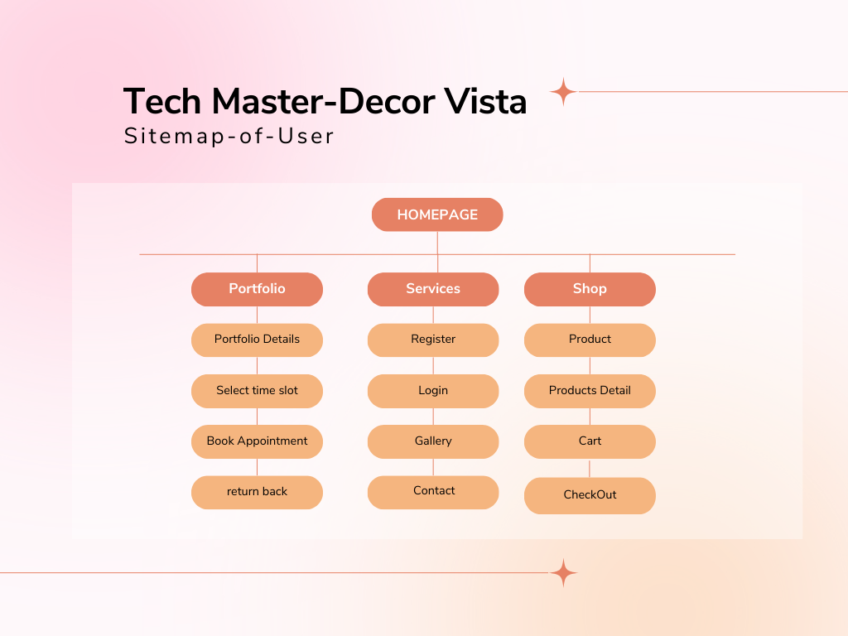User Sitemap: